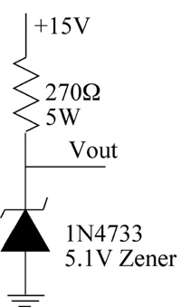
Task 1: The Voltage Reference

Build the circuit shown in the figure to the left.
This is a Zener reference, making use of the property of Zener (and Avalanche) diodes that gives them a reverse breakdown voltage that is nearly independent of the current flowing in the diode.

a) Measure Vout and compare to the theoretical value, noting that the Zener has a 5% tolerance.
Vout is 5.12V, which is pretty close to the Zener’s 5.1V rating.

b) What is the current flowing in the Zener?
V=IR → (15.04 – 5.12) = I*270 → I = 36.74 mA.

c) Connect a 1000Ω resistor between Vout and ground in order to draw current from the reference.
d) Measure the voltage at Vout and compute the current being drawn from the regulator. Repeat with resistors of 500Ω, 220Ω, and 150Ω, 110Ω, and 75Ω. (You will have to make some of these resistors from combinations of other values. This is important as it spreads the heat load among the resistors.)
Resistance Voltage
1000 5.09
500 5.08
220 5.04
150 4.99
110 4.29
75 3.23

e) Plot the output voltage as a function of the output current.
Note that theory predicts that the graph should look like two straight lines. That should guide you in connecting your dots.
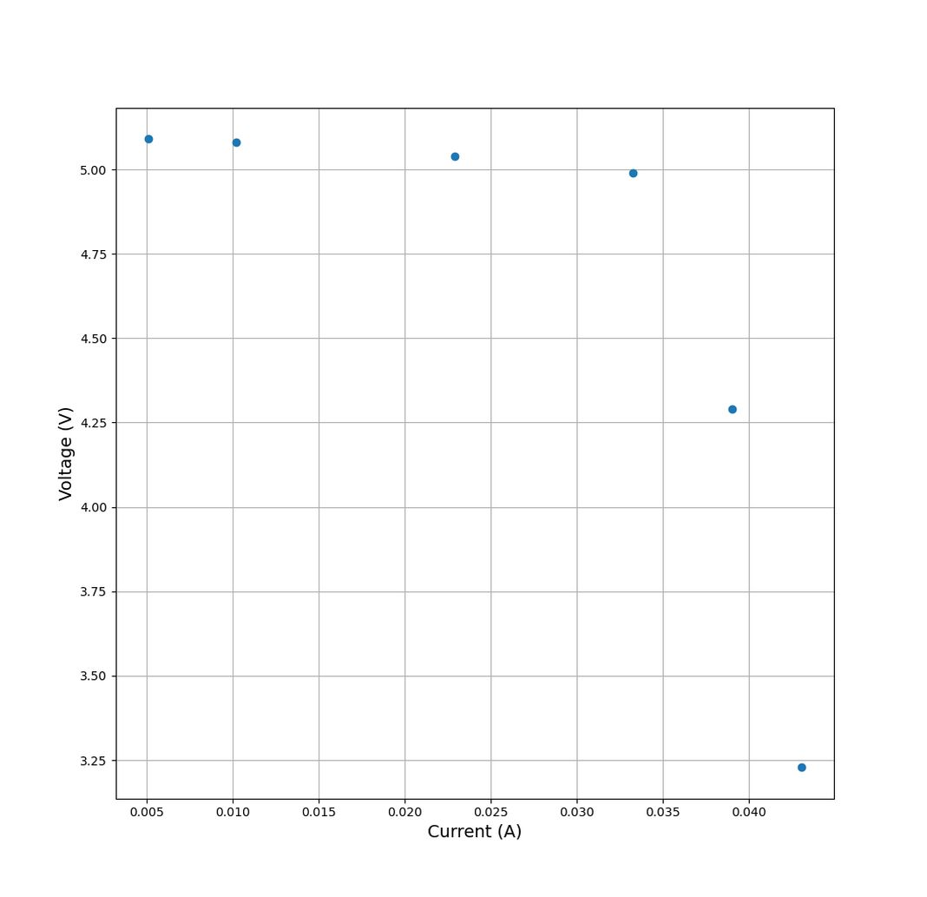
The line of best fit for the first cluster is y=-3.4x+5.11, and the line of best fit for the second cluster of data (the last two points) is y = -258.54x + 14.37.
Their intersection is at (0.03629, 4.987).

f) Compare the maximum current that can be drawn before the output starts to fall significantly to the Zener current in part 1 and use your result to explain how the regulator works.
The maximum current that can be drawn before the output starts to fall significantly is therefore 36.29 mA. This is pretty close to the Zener current of 36.74 mA.

g) What is the output (slope) resistance (Thévenin resistance) of the regulator in the region before the voltage falls steeply? Compare this to the 270 Ω resistor in the circuit.
(Remember slope resistance is change in voltage over change in current.)
The slope resistance in the region before the voltage falls is 3.4 Ohms, which is way smaller than the 270 Ohm output resistance of the simple voltage source.

Task 2: The Voltage Regulator
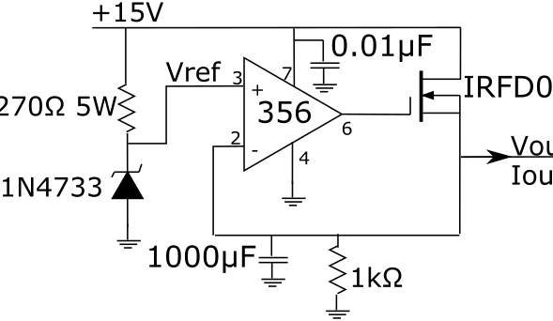
Using the 5.1V Zener as a voltage reference, build the simple voltage regulator of the figure on the right.

a) Measure the output voltage.
The output voltage is 5.08 V.

b) Use the golden rules to explain how the circuit works and use your understanding of FETs predict what will happen to the FET gate voltage and to Vout as more current is drawn from the output.
When more current is drawn from the output, the FET has to activate further. Thus, the FET’s gate-source voltage has to rise. Since the source voltage is Vout, which is constant, the gate voltage has to rise.

c) Measure the output voltage as a function of the output current by putting several 220Ω resistors in parallel. Do not exceed 200mA total output current (the limit of the FET).
NOTE that the FET will heat up if you let current flow for more than a few seconds. In order to see the gate voltage behave in the predicted fashion you will need to keep turning the circuit off and only have it on long enough to measure the output and gate voltages.
NOTE that you know the total resistance that you added to the output so you don't have to MEASURE the output current.
220s Output Gate
0 5.08 8.70
1 5.08 8.95
2 5.08 9.04
3 5.08 9.12
4 5.08 9.18
5 5.08 9.20
6 5.08 9.24
7 5.08 9.28
8 5.08 9.32

d) Plot the output voltage and the gate voltage as a function of the output current. Paste your plot below.
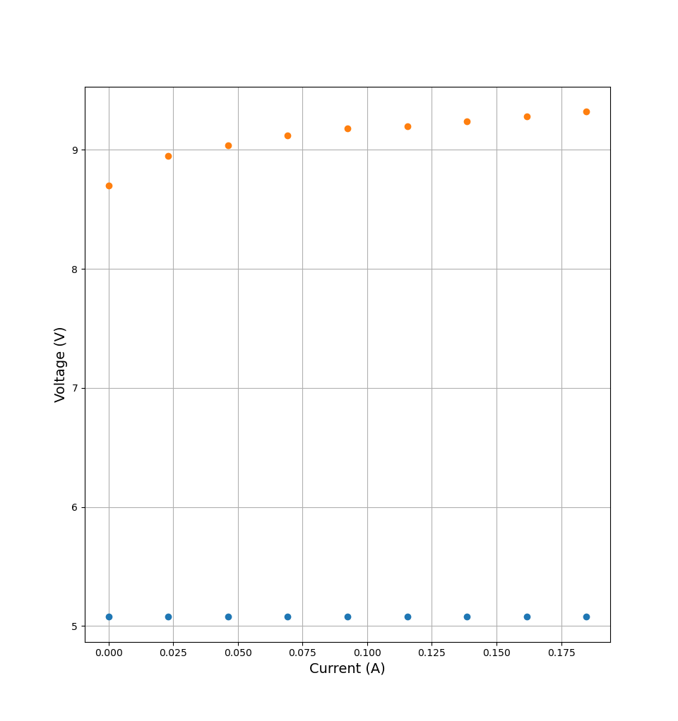
(Gate voltage shown in orange, output voltage shown in blue)

e) Does the gate voltage agree with your prediction? (Explain!)
Yes. The gate voltage had to rise to further activate the FET.

f) Does the output voltage agree with your prediction? (Explain!)
Yes. The voltage regulator regulated voltage successfully.

g) Discuss what you learn of the Thévenin output resistance of this voltage regulator and why that is good or bad.
The output resistance of this regulator is low because we don’t see any difference in voltage with low loads. This is good because it makes the regulator’s output consistent across loads.

h) How would you add two 1k resistors to the circuit to make it into a ~10 V power supply instead of a 5 V supply? Draw a circuit and paste it below.
You drew this circuit on the board.

i) Explain what you did.
I added an extra 1k resistor in series between the FET and the other 1k resistor. Because the golden rules dictate that the op-amp inputs be at equal voltages, and the non-inverting input is held at 5.1V, we need the inverting input to be 5.1V too. Adding the resistor forces a 50% voltage drop across it, so the voltage at Vout must be 2 * 5.1V in order for the inverting input to be 5.1V.

j) Does it work?
Yes.

